React context lesson 4

Now want to consume context provider from the two components ie: get the data

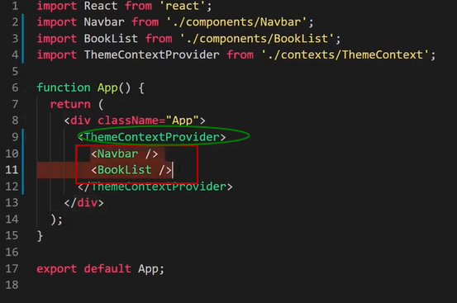

that we pass into provider here

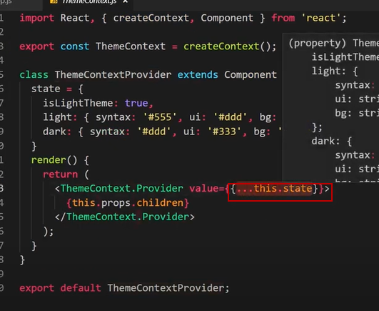

**Can do this using context type class components not in functional components**

Using context type here

Context / context type -look up the component tree for the first time it finds a provider for this context. Finds it in App JS in the ThemContextProvider

the context type of this component we want to use is the ThemeContext

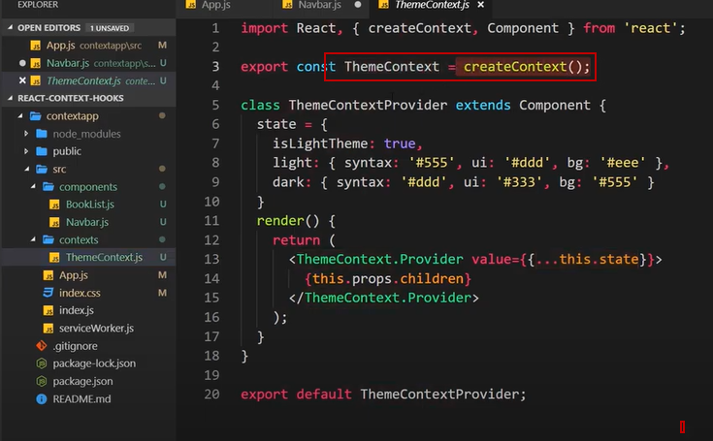

The context provider -provides the context – has access to the value property

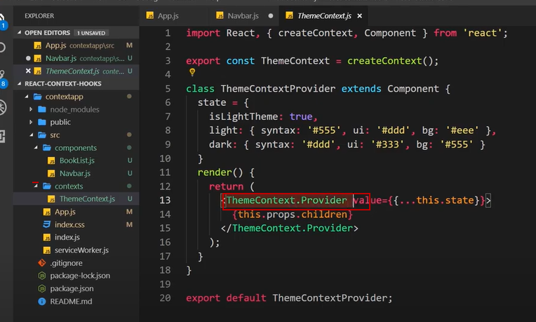

this.context in the Navbar.js

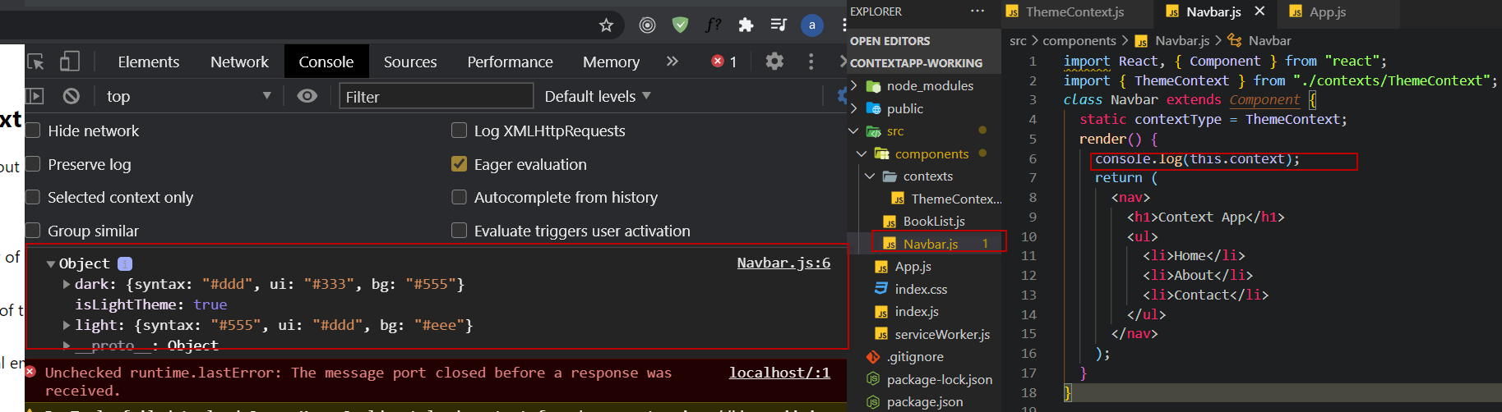

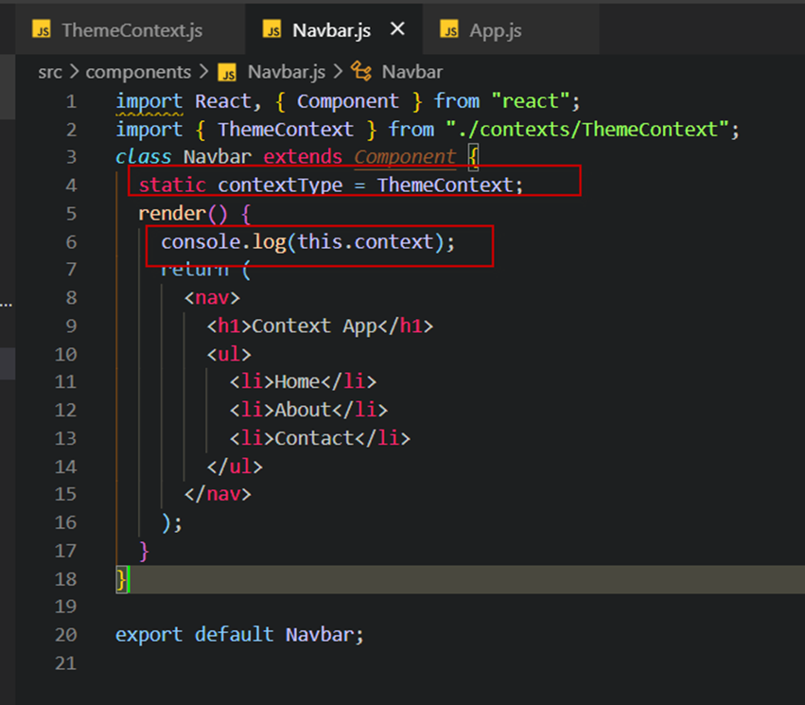

Putting the theme values into const , destructuring and adding the theme styles

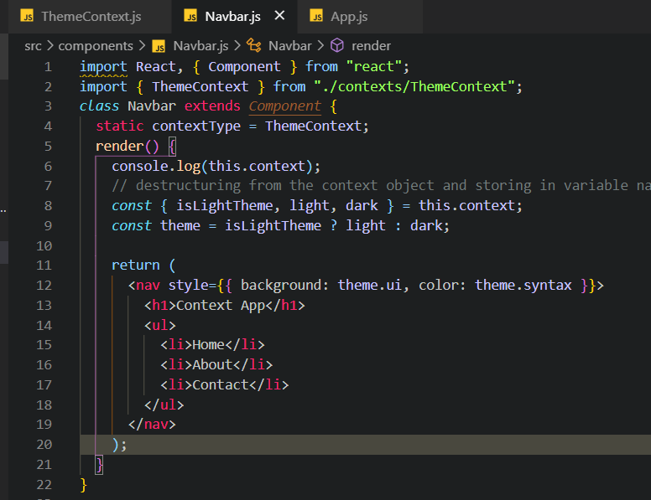

In react dev tools

